Code Example 1: Load and Preprocess MNIST Data
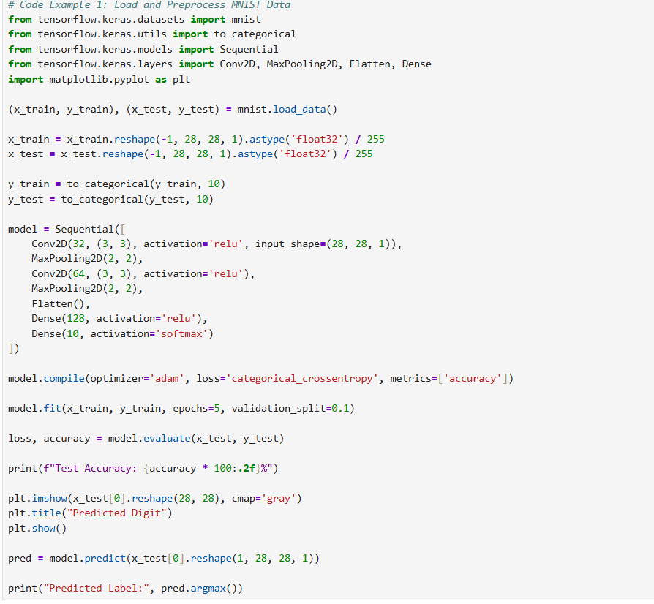

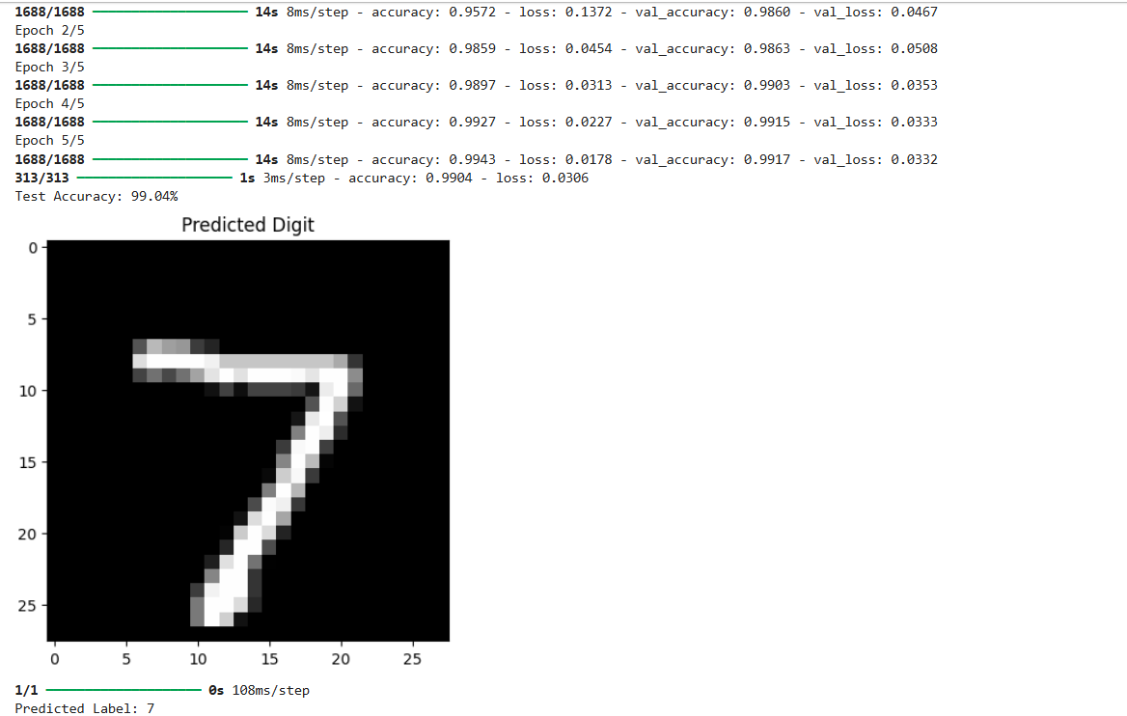

Code Example 2: Handwritten Digit Recognition Using Neural Networks (Keras & TensorFlow)
A fintech startup is building a mobile banking application that supports remote cheque deposit and digital form filling. One major challenge is accurately reading handwritten digits on scanned forms—such as account numbers, routing codes, and amounts—written by users with varying handwriting styles and image quality.
Traditional OCR systems perform poorly with unconstrained handwriting due to noise, distortion, and inconsistent writing. The company decides to implement a deep learning-based digit recognition model to solve this problem with high accuracy and robustness.
They choose Keras with TensorFlow backend for its simplicity, flexibility, and strong support for neural network development.
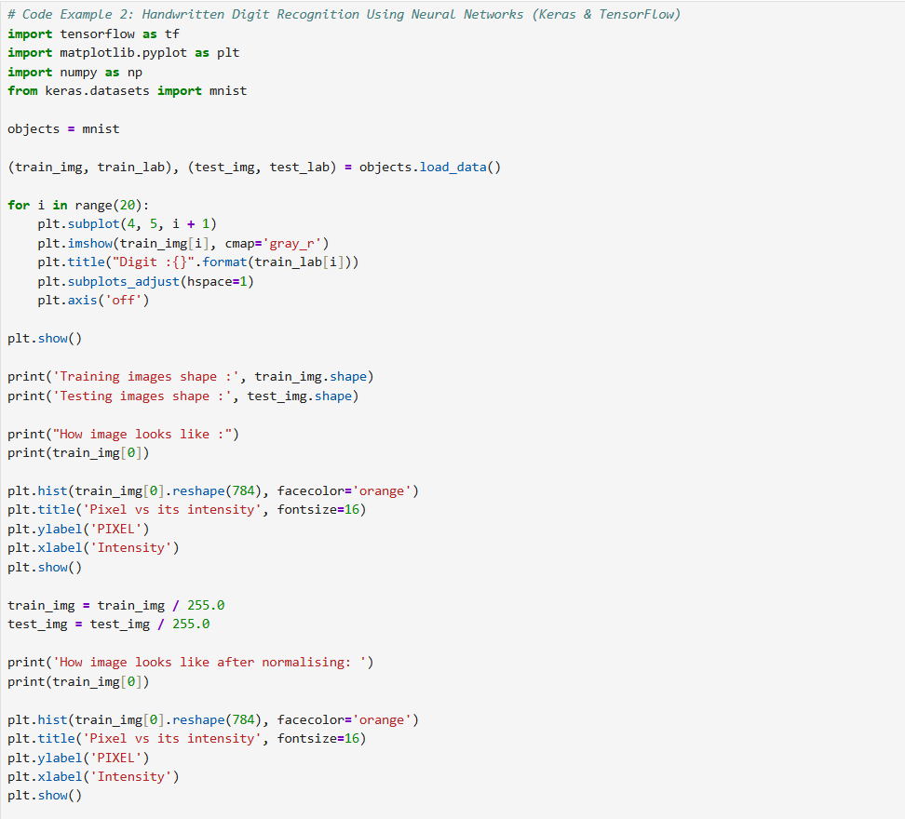

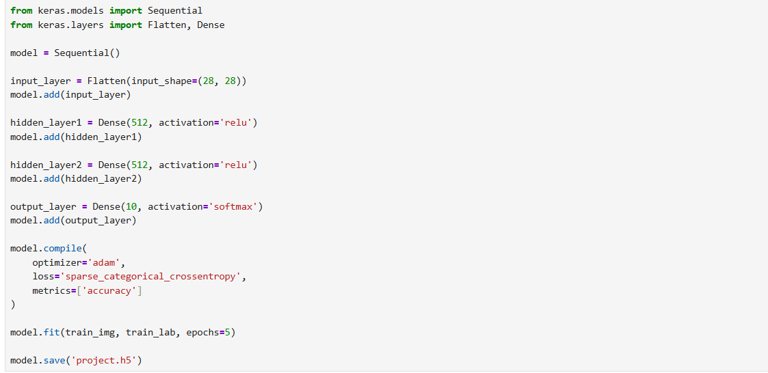

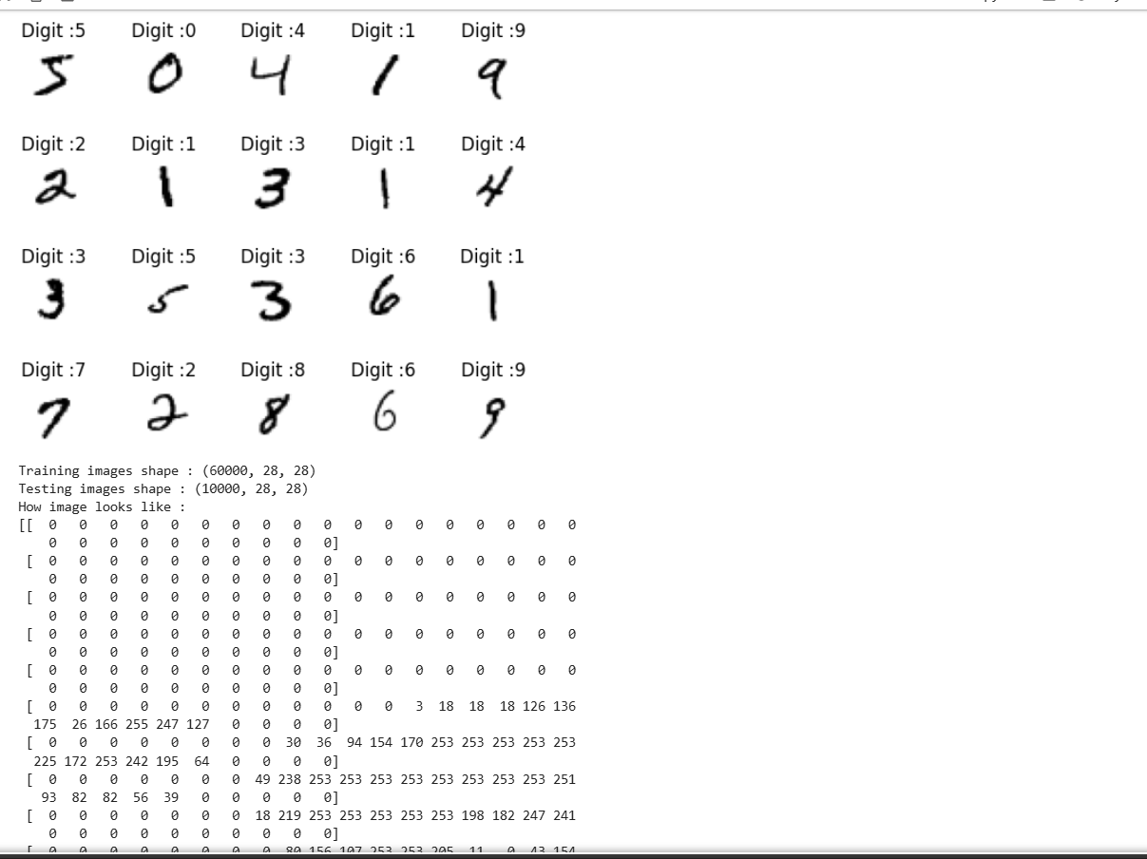

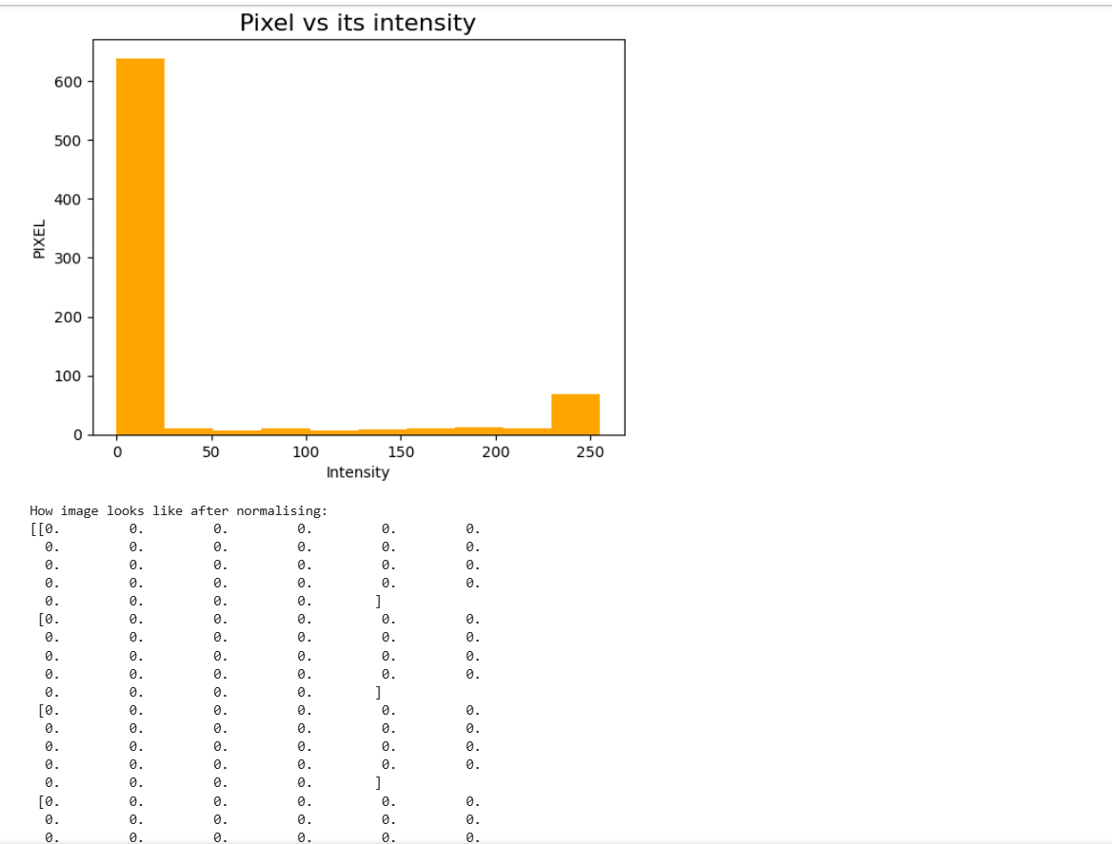

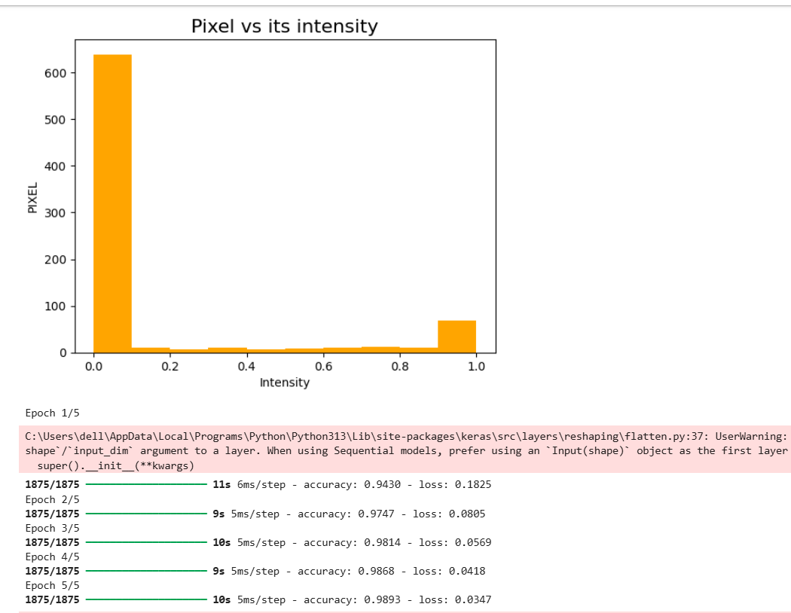

Case Study : Postal Code Recognition in Postal Systems
A national postal service wants to automate the sorting of mail by recognizing handwritten zip codes on envelopes. Manual sorting is time-consuming and prone to error, especially during peak mailing seasons.
Objective:
Implement a neural network that can recognize handwritten digits (0–9) from scanned postal codes to enable automatic mail categorization and routing.
